**Title: Homicides increase variation on lifespans in Mexico and its States, 2005-2015**

**Authors:** José Manuel Aburtoa & Hiram Beltrán-Sánchezb

**Author affiliations:**

a University of Southern Denmark, Odense 5000, Denmark.

b Department of Community Health Sciences at the Fielding School of Public Health and California Center for Population Research, Center for Health Sciences, Los Angeles, California, USA.

**Corresponding author:**

José Manuel Aburto

Email: [jmaburto@health.sdu.dk](mailto:jmaburto@health.sdu.dk)

Tel. number: +45 65 50 94 16

Affiliation: EBB/Epidemiology, Biostatistics and Biodemography; University of Southern Denmark.

Address: J.B. Winsløws Vej 9. DK-5000 Odense C, Denmark

**Classification:** Violence, Population Health and Demography

**Keywords:** violence, homicide, lifespan variation, life expectancy, demography.

**Abstract [Max 250 words]:**

**\maintext[~ 4400 words]**

**Introduction**

Violence has become a major public health issue in Latin America since the end of the 20th century [1]. This region currently experiences the highest homicide rate in the world (over 16.3 per 100,000 people), with some countries in Central America, including Mexico, undergoing an upsurge in homicides since the first years of the 21st century [2]. In Mexico, for example, homicide rates doubled between 2007 and 2012 (from 9.3 to 18.6) [3]. As a result of this increase, along with an increasing burden of diabetes, male life expectancy in Mexico stagnated in the period 2000-10 [4]. At the subnational level, evidence indicates that gains in life expectancy due to causes amenable to medical service throughout 2000-10, such as infectious, respiratory diseases and birth conditions, were wiped out by the increase of homicide and diabetes mortality in each of the 32 states in Mexico with large regional variations [5].

Trends in life expectancy are important and have been studied in Mexico and its states [4-6]. However, life expectancy masks substantial heterogeneity in individual mortality trajectories [7, 8], referred here as lifespan variation. Variability in ages-at-death expresses a fundamental inequality among individuals [9], and it has arisen as an important topic since it addresses the growing interest in health inequalities [10]. Studying both life expectancy and lifespan variation adds an important dimension to the study of population health because these indicators represent individuals’ decisions based not only on their expected lifetime, but also on the uncertainty in their timing of death [11]. Most studies have found a negative association between these two measures, suggesting that as life expectancy increases, variation in lifespans decreases [8, 12-14]. However, at the subnational level some evidence suggests that increases in lifespan variation may simultaneously occur with increases in life expectancy, mostly due to a slowdown in mortality improvements in working ages (e.g., premature mortality) [15, 16]. This is particularly relevant for countries that have experienced an upsurge in homicides since this increase has mainly affected working age individuals.

In Mexico, for example, homicide mortality is concentrated between ages 15 and 50, affecting mainly males. We thus hypothesize that the Mexican population may be experiencing increases in lifespan variation due to the rise in homicides in tandem with improvements in overall life expectancy at the subnational level. We also expect larger changes in lifespan variation among men and uneven variability across states in the country due to the changing dynamics of violence and homicides in Mexico [17]. For instance, states in the Northern part of Mexico (e.g., Chihuahua, Durango and Sinaloa) experienced the largest losses in life expectancy due to homicides between 2005-10 [5] and it is likely they also exhibit large lifespan variation in the country, although this impact may be larger in other states as homicides spread throughout the entire country in recent years [18]. However, since the more pronounced fluctuation in age-specific mortality occurred over working ages [5], it is unclear what the net effect would be on lifespan variation but it certainly had an effect on premature mortality. On the other hand, there have been mortality improvements in the country at younger ages, which have been Mexico’s priority since the 1990s (e.g., birth-related conditions) [19, 20]. These improvements could have a substantial effect on reducing variation in lifespans, particularly in historically poor states, which are mostly concentrated in the South.

This paper makes three main contributions. First, it contributes to the literature on lifespan variability and inequalities in health in the context of rising homicides. Most literature in this area focuses on social determinants of health (e.g., socioeconomic status and health risk factors) as proximate determinants of lifespan variability and health inequality. In contrast, our paper highlights the role of violence, and its ultimate consequence in the form of homicides, among young adults on increasing lifespan variability. A second contribution is its focus on Mexico. Mexico is experiencing a growing violence associated with the war on drugs that started in the last decade, making the increase in homicides a serious health policy concern. Understanding the consequences that homicides have on population health is important for Mexican policy makers, and for policy makers in other countries that are experiencing similar increases in homicides such as Honduras and El Salvador in Central America. Finally, this analysis contributes to our knowledge of regional variation in lifespans.

.

In this article we use ‘years of life lost’ ($e^{†}$) as an indicator of lifespan variation [21]. This measure allows us to thoroughly analyze premature mortality, and it also has an important public health interpretation as it quantifies the average life expectancy loss attributable to death [22] . We analyzed how lifespan variation changed over a 20-year period, from 1995 to 2015, for females and males in Mexico and its 32 states, and determined the ages and causes of death that contributed the most to the observed change in life expectancy and lifespan variation.

**Study data and Methods**

We used data on deaths from vital statistics files publicly available through the Mexican National Institute of Statistics and Geography [23]. These data include information on cause-of-death by age, sex, and place of occurrence from 1995 to 2015. Additionally, we used population estimates corrected for completeness, age misstatement, and international migration available from the Mexican Population Council to construct age-specific death rates by age, sex and state [24].

***Cause-of-death classification***

We classified deaths into eight categories according to previous studies targeting the main causes of death in Mexico [5, 25] using the concept of amenable/avoidable mortality [26, 27]. This concept assumes that there are some conditions that should not cause death in the presence of timely and effective medical care. Deaths due to these conditions are a proxy for the performance of health care systems [26].

The first category includes conditions amenable to medical service. It refers to mortality that could be reduced by primary or secondary prevention and timely medical care (for example, birth conditions, infectious and respiratory diseases). We separately analyzed diabetes, ischemic heart diseases (IHD), lung cancer, cirrhosis, and road traffic accidents because the first two are leading causes of death in Mexico [4], and all of them are amenable to health behavior and medical service [5]. The last (eighth) category includes residual causes of death labeled ‘Rest’ (see Supplemental Material for specific details on deaths classification). To mitigate biases due to misclassification of causes of death, we focus on deaths occurring below age 85 since coding practices above that age are less reliable due to the presence of comorbidities.

We study two comparable 10-year periods, between 1995 and 2005, and from 2005 to 2015. This allowed us to identify a period of mortality improvements (1995-2005) in which life expectancy increased by 2.1 and 4.3 years for males and females, respectively [24] and homicide rates fell down among young ages [28]. The second period (2005-2015) is characterized by a period of life expectancy stagnation, particularly for males (around 72 years) and slow progress for females (from 76.7 to 77), accompanied by an unprecedented rise in homicide mortality [5].

***Lifespan variation indicator***

Several dispersion measures have been proposed to analyze lifespan variability [8, 29]. In this study, we use $e^{†}$ as a dispersion indicator and we refer to it as “lifespan variation”. It is defined as the average remaining life expectancy when death occurs, or life years lost due to death [13, 21]. For example, if in a cohort of newborns all die at the same age then the value of $e^{†}$ is zero; to the extent that death occurs at different ages, those who die “prematurely” will die before their expected lifetime contributing lost years to life disparity. In lifetable notation, it is defined as:

$$e^{†}= -\int_{0}^{ω}{l\left(x\right)\text{μ(}x)e\text{(}x)\text{d}x}=-\int_{0}^{ω}{l\left(x\right)\text{ ln}l\left(x\right)\text{d}x}$$

where $l\left(x\right)\text{, } \text{μ(}x), e\text{(}x)$ and $ω$ are the survival function, the force of mortality, life expectancy at age $x$, and the open-aged interval, respectively.

This indicator was chosen because it has an easy to understand interpretation and it is also easy to decompose allowing us to quantify the impact of age and cause-specific mortality on changes in life disparity over time [22, 30]. An additional advantage is the high correlation between $e^{†}$ and other measures of variability in ages at death (e.g., life table entropy, coefficient of variation, or the Gini coefficient) which suggests that our main results would be very similar to those obtained with any of these additional measures [29].

***Demographic and statistical methods***

To mitigate random variations in cause-of-death classification, we smoothed cause-specific death rates over age using a 1-d p-spline separately by year, sex and state [31]. We then rescaled the smoothed cause-specific deaths to all-cause death rates to maintain the overall mortality level by year, sex, and state. Using these mortality rates we computed period life tables for males and females for each year-state in the study period (1995 to 2015) following standard demographic methods [32]. Finally, we computed life expectancies (e0) and life disparities ($e^{†}$) for each year and estimated the age- and cause-specific contributions to differences between the periods 1995-2005 and 2005-2015, using standard decomposition techniques [33]. All analyses were carried out using R [34] and are fully reproducible from the Supplemental Material. In addition, to analyze state-specific mortality profiles and changes along other period from 1995 to 2015 we created an interactive app to perform sensitivity analyzes available [here](https://goo.gl/H1y1R6).

**Results**

**Changes in life expectancy and lifespan variation at the national level**

As expected, results for males show the largest impact of homicides on life expectancy and life span variation over both time periods (Figures 1-4). We thus focus on these results (results for females are shown in Supplemental Material, figures S1-S4).

Figure 1 shows age- and cause-specific contributions to the change in male life expectancy at birth between 1995 and 2005 (Panel A) and between 2005 and 2015 (Panel B). Vertical values enclosed in rectangles represent age-specific contributions (in years), while the length of the bars correspond to cause-specific contributions by age (also in years). Overall cause-specific contributions across all ages are shown in the panel’s legend in parenthesis.

Among men, life expectancy at birth increased about twice as fast in 1995-2005 (2.1years) than in 2005-2015 (1.05 years). Most causes of death contributed to the improvement in life expectancy in 1995-2005 (except for diabetes, heart disease and accidents) implying that their underlying mortality rates reduced over the period. Importantly, homicide rates were declining in 1995-2005 which contributed to about one-fourth (0.45 years) of the overall gain in life expectancy. Moreover, about 78% (0.36 years) of this contribution was due to reductions in homicide mortality between ages 15-49 (red bars in Figure 1, panel A). In contrast, the slowed down improvement in life expectancy in 2005-2015 was mainly the result of rising rates of homicide and heart disease, hence their negative contributions to the change. Contrary to the previous decade, about 98% (-0.27 years) of the negative contributions due to homicides resulted from worsening mortality rates between ages 15-49. Women increased life expectancy by 1.3 years in 1995-2005 mainly due to medically amenable conditions offset by increasing diabetes mortality. Between 2005 and 2015 increased by an additional year due to continuous progress in causes amenable to medical service.

During this period, the effect of homicides was negative, albeit negligible compared to males.

[Figure 1 about here]

Figure 2 shows similar information to Figure 1 corresponding to lifespan variation ($e^{†}$). Lifespan variation decreased throughout the entire period 1995-2015 for males. However, stronger reductions on $e^{†}$ were made between 1995 and 2005 changing from 16.5 to 15.3 than in the following decade, 2005-2015, when reductions represented almost half of that in the preceding period. Homicides and conditions amenable to medical service account for most of the decrease in $e^{†}$ between 1995 and 2005 for males, -0.24 and -0.61 years respectively. Diabetes, contributed negatively to the change in lifespan variation, mainly because of mortality deterioration above age 70. Between 2005 and 2015, the increase in homicide mortality had a positive impact on lifespan variation of 0.16 years in ages below age 60 for males. Opposing this, improvements in mortality in road traffic accidents (-0.11) and cirrhosis (-0.11) decreased variation in lifespans. Importantly, deteriorations in diabetes mortality in ages above 70 continued helping reducing lifespan variation. For females, lifespan variation decreased throughout the period 1995-2015 from 14.3 to 13.4 years. Most of this was due to progress in the first years of life and from amenable causes.

[Figure 2 about here]

**Changes and cause-specific contributions to life expectancy and lifespan variation at state level**

Figure 3 shows changes in life expectancy (panel A) and in lifespan variation (panel B) for males in each of the 32 states in Mexico between 1995 and 2005 (blue dots) and between 2005 and 2015 (red triangles) by region . Every state increased life expectancy between 1995 and 2005 (panel A) with an additional year. However, between 2005 and 2015, the progress was slowed down and every state in Mexico experienced lower gains in life expectancy than the previous decade. Some states even experienced reductions in life expectancy, such as Chihuahua.

Opposing trends in life expectancy, lifespan variation (panel B) was reduced in every state between 1995 and 2005, with major improvements in the South of the country in states such as Chiapas, Oaxaca and Puebla. Between 2005 and 2015, two states in the North increased variation in lifespans: Chihuahua and Nuevo León (both bordering with Texas in the US), and the rest experienced smaller decreases than in the period 1995-2005.

[Figure 3 about here]

Figure 4 shows the contribution (in years) of causes amenable to medical service (AMS), diabetes, homicides and road traffic accidents to changes in lifespan variation between 1995 and 2005 (blue dots) and between 2005 and 2015 (red triangles) for males. We show these causes of death because they contributed the most to changes in life expectancy since 2000 [4]. For contributions from all cause-of-death categories and females’ results see Supplementary Material figures S4-S7.

Every state decreased lifespan variation due to medically amenable causes of death and homicides between 1995 and 2005. The states showing the larger reductions were mostly concentrated in the southern region of Mexico such as Chiapas, Oaxaca, Puebla, Guerrero and Morelos. Between 2005 and 2015, conditions amenable to medical service contributed to reductions in lifespan variation in most states, with the exceptions of Nayarit and Nuevo León. Homicides increased variation in most states between 2005 and 2015 (except in Durango, Nayarit and Campeche). The increase in homicide mortality in this period mainly affected the states of Guerrero (in the South), Chihuahua and Sinaloa in the North, and Colima in the central region. In these states the increases in lifespan variation were even larger that the improvements (decreases) made from 1995 to 2005. Diabetes show negligible contributions. Females experienced substantial reductions in lifespan variation due to AMS. Diabetes and IHD also helped reducing variation in lifespans in the overall period 1995-2015, albeit with smaller contributions. The effect of the rest of causes of death was negligible, however the effect of homicides on female lifespan variation can be seen in the state of Guerrero.

**Discussion**

In this study, we quantified the effect that the increase of violence, through homicides, has contributed to changes in life expectancy and lifespan variation in Mexico and its 32 states over the last two decades. Overall, life expectancy has slowed down and lifespans have become more variable in the decade 2005-15 due to and offsetting effect of increasing premature mortality due to homicides and large progress in medically amenable conditions at very young ages. By analyzing lifespan variation in every state of Mexico we could disentangle the increasing inequality within states in terms of lifespans. Specifically, we found that every state in the country experienced lower gains in life expectancy and slower progress in reducing lifespan variation in 2005-15 compared to the previous decade. Although homicide levels are not evenly shared across the country, in 29 states homicides increased lifespan variation.

**Funding**

**References**

1. Briceño-León, R., A. Villaveces, and A. Concha-Eastman, *Understanding the uneven distribution of the incidence of homicide in Latin America.* International Journal of Epidemiology, 2008. **37**(4): p. 751-757.

2. Drugs, U.N.O.o. and Crime, *Global study on homicide 2013: trends, contexts, data*. 2013: UNODC.

3. Gamlin, J., *Violence and homicide in Mexico: a global health issue.* The Lancet, 2015. **385**(9968): p. 605-606.

4. Canudas-Romo, V., V.M. García-Guerrero, and C.J. Echarri-Cánovas, *The stagnation of the Mexican male life expectancy in the first decade of the 21st century: the impact of homicides and diabetes mellitus.* J Epidemiol Community Health, 2015. **69**(1): p. 28-34.

5. Aburto, J.M., et al., *Homicides in Mexico reversed life expectancy gains for men and slowed them for women, 2000–10.* Health Affairs, 2016. **35**(1): p. 88-95.

6. Gómez-Dantés, H., et al., *Dissonant health transition in the states of Mexico, 1990–2013: a systematic analysis for the Global Burden of Disease Study 2013.* The Lancet, 2016. **388**(10058): p. 2386-2402.

7. Edwards, R.D. and S. Tuljapurkar, *Inequality in life spans and a new perspective on mortality convergence across industrialized countries.* Population and Development Review, 2005. **31**(4): p. 645-674.

8. Wilmoth, J.R. and S. Horiuchi, *Rectangularization revisited: Variability of age at death within human populations*.* Demography, 1999. **36**(4): p. 475-495.

9. Tuljapurkar, S., *The final inequality: variance in age at death*, in *Demography and the Economy*. 2010, University of Chicago Press. p. 209-221.

10. Marmot, M., *Inequalities in health.* New England Journal of Medicine, 2001. **345**(2): p. 134-135.

11. van Raalte, A.A., et al., *More variation in lifespan in lower educated groups: evidence from 10 European countries.* International Journal of Epidemiology, 2011: p. dyr146.

12. Engelman, M., V. Canudas-Romo, and E.M. Agree, *The implications of increased survivorship for mortality variation in aging populations.* Population and Development Review, 2010. **36**(3): p. 511-539.

13. Vaupel, J.W., Z. Zhang, and A.A. van Raalte, *Life expectancy and disparity: an international comparison of life table data.* BMJ open, 2011. **1**(1): p. e000128.

14. Colchero, F., et al., *The emergence of longevous populations.* Proceedings of the National Academy of Sciences, 2016. **N.A**(N.A): p. N.A.

15. Sasson, I., *Trends in life expectancy and lifespan variation by educational attainment: United States, 1990–2010.* Demography, 2016. **53**(2): p. 269-293.

16. van Raalte, A.A., P. Martikainen, and M. Myrskylä, *Lifespan variation by occupational class: compression or stagnation over time?* Demography, 2014. **51**(1): p. 73-95.

17. Flores, M. and A. Villarreal, *Exploring the spatial diffusion of homicides in Mexican municipalities through exploratory spatial data analysis.* Cityscape, 2015. **17**(1): p. 35.

18. Espinal-Enríquez, J. and H. Larralde, *Analysis of México’s Narco-War Network (2007–2011).* PloS one, 2015. **10**(5): p. e0126503.

19. González-Pier, E., et al., *Mexico's path towards the Sustainable Development Goal for health: an assessment of the feasibility of reducing premature mortality by 40% by 2030.* The Lancet Global Health, 2016. **4**(10): p. e714-e725.

20. Sepúlveda, J., et al., *Improvement of child survival in Mexico: the diagonal approach.* The Lancet, 2006. **368**(9551): p. 2017-2027.

21. Vaupel, J.W. and V. Canudas-Romo, *Decomposing change in life expectancy: A bouquet of formulas in honor of Nathan Keyfitz’s 90th birthday.* Demography, 2003. **40**(2): p. 201-216.

22. Shkolnikov, V.M., et al., *Losses of expected lifetime in the United States and other developed countries: methods and empirical analyses.* Demography, 2011. **48**(1): p. 211-239.

23. INEGI. *National Institute of Statistics: Micro-data files on mortality data 1995-2015*. 2017 [cited 2017 21/4/2017]; Available from: <http://www.beta.inegi.org.mx/proyectos/registros/vitales/mortalidad/default.html>.

24. CONAPO. *Mexican Population Council: Population estimates.* 2017 [cited 2017 21/4/2017]; Available from: <https://datos.gob.mx/busca/dataset/activity/proyecciones-de-la-poblacion-de-mexico>.

25. Franco-Marina, F., et al., *La mortalidad en México, 2000-2004. Muertes Evitables: magnitud, distribución y tendencias.* Dirección General de Información en Salud, Secretaría de Salud. México, 2006: p. 2.

26. Nolte, E. and C.M. McKee, *Measuring the health of nations: updating an earlier analysis.* Health affairs, 2008. **27**(1): p. 58-71.

27. Nolte, E. and M. McKee, *Measuring the health of nations: analysis of mortality amenable to health care.* Bmj, 2003. **327**(7424): p. 1129.

28. Frías, S.M. and D. Finkelhor, *Homicide of children and adolescents in Mexico (1990–2013).* International Journal of Comparative and Applied Criminal Justice, 2017: p. 1-17.

29. van Raalte, A.A. and H. Caswell, *Perturbation analysis of indices of lifespan variability.* Demography, 2013. **50**(5): p. 1615-1640.

30. Zhang, Z. and J.W. Vaupel, *The age separating early deaths from late deaths.* Demographic Research, 2009. **20**(29): p. 721-730.

31. Camarda, C.G., *MortalitySmooth: An R Package for Smoothing Poisson Counts with P-Splines.* Journal of Statistical Software, 2012. **50**: p. 1-24.

32. Preston, S.H., P. Heuveline, and M. Guillot, *Demography. Measuring and Modeling Population Processes*. 2001: Blackwell.

33. Horiuchi, S., J.R. Wilmoth, and S.D. Pletcher, *A decomposition method based on a model of continuous change.* Demography, 2008. **45**(4): p. 785-801.

34. Team R Core, *R: A language and environment for statistical computing.* 2013.

**Tables and Figures**

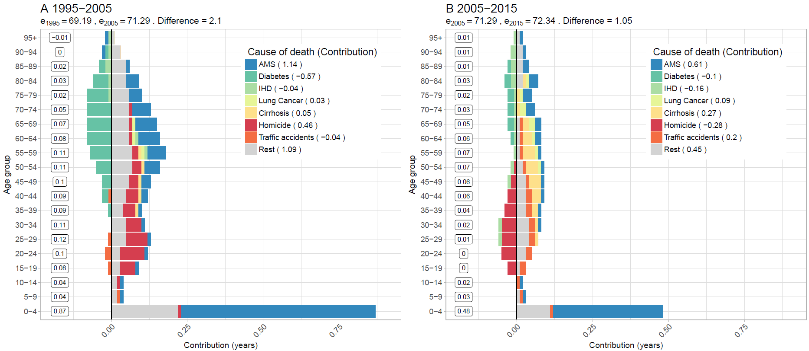**Figure 1. Age-cause specific contributions to the changes in national life expectancy (**e0**) for males. Panel A refers to 1995-2005 and panel B to 2005-2015. Note: Numbers in boxes are age-specific contributions.**

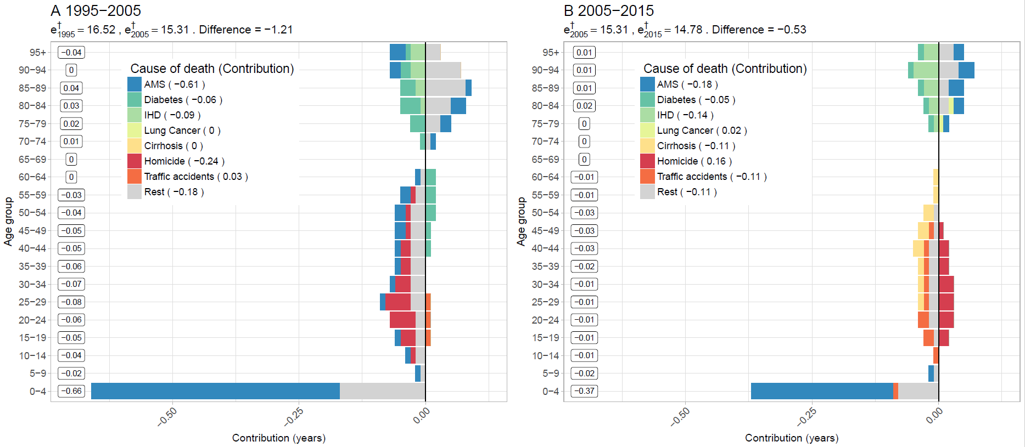**Figure 2. Age-cause specific contributions to the changes in national lifespan variation ($e^{†}$) for males. Panel A refers to 1995-2005 and panel B to 2005-2015. Note: Numbers in boxes are age-specific contributions.**

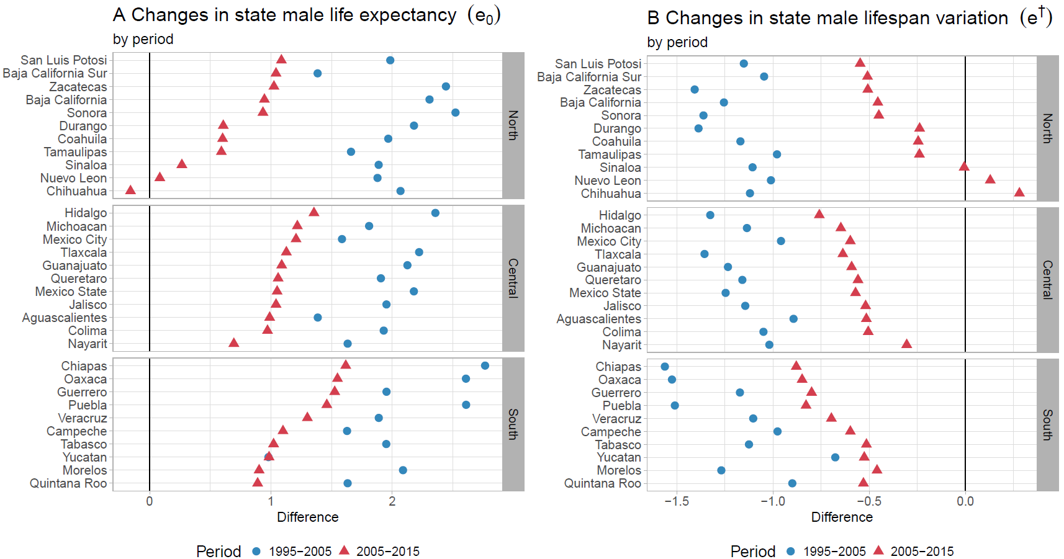**Figure 3. Changes in male life expectancy (**e0**) (panel A) and male lifespan variation ($e^{†}$) (panel B)**

**by state for the periods 1995-2005 and 2005-2015.**

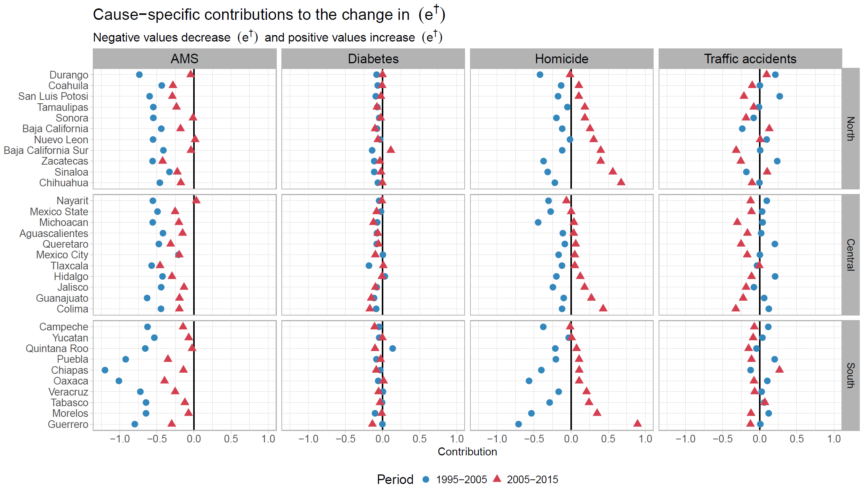**Figure 4. Cause-specific contributions to changes in male lifespan variation ($e^{†}$) by state for the periods 1995-2005 and 2005-2015.**